|  |  |
| --- | --- |
| AIN SHAMS UNIVERSITYFACULTY OF ENGINEERINGi-CREDIT HOURS ENGINEERING PROGRAMS *Computer Engineering and Software Systems Program* |  |

|  |  |
| --- | --- |
| ***Spring 2021*** | **Course Code: *CSE 472*** |
| **Artificial Intelligence** | |

**Course Project**

Submitted by

|  |  |  |
| --- | --- | --- |
|  | **Name** | **ID** |
| **1** | **Yomna Hussien Mohamed Abd El Hamid** | **18P5794** |
| **2** | **Sherif Ahmed Naiem Mohamed** | **18P6546** |
| **3** | **Andrew Saied Labib Barsom** | **18P5886** |

**AI Searching Techniques GUI Manual**

**Steps to run the project:**

1. Enter node 1, node 2 and edge weight between them then click on “Add Nodes” button, then repeat until you enter all the nodes you want in your graph

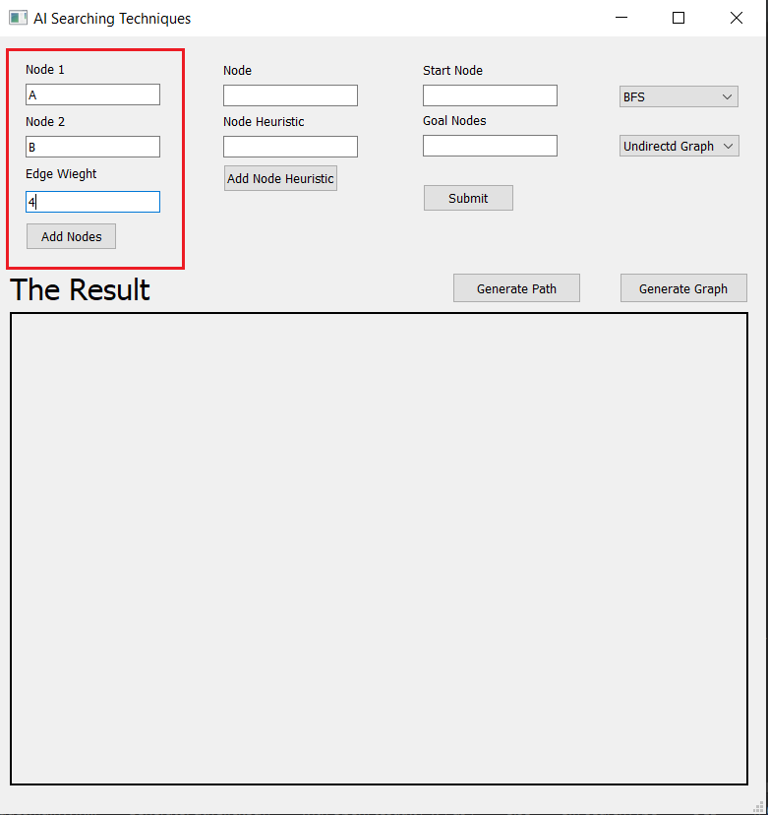

1. 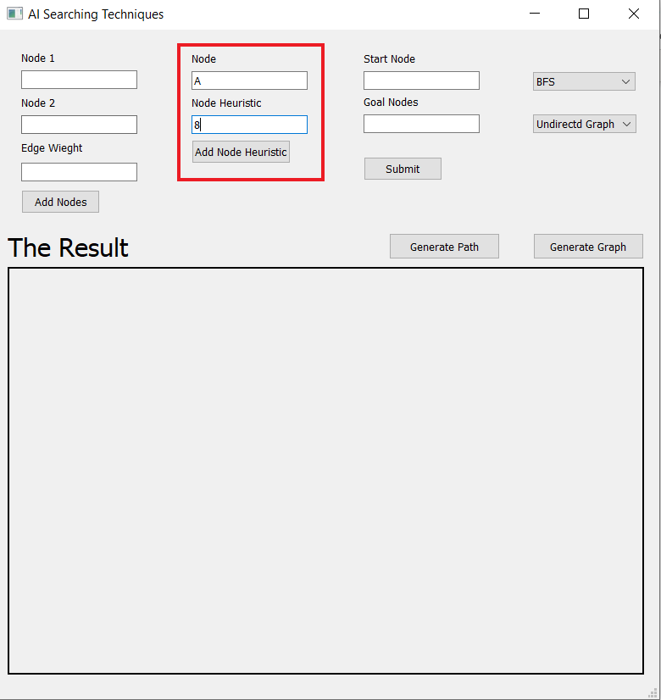Enter node and its heuristic then click on “Add Node Heuristic” button, then repeat until you enter all the nodes
2. Enter start node and goal node then click “Submit” button, then keep entering goal nodes that you desire, and after each goal node you enter, click on the “Submit” button

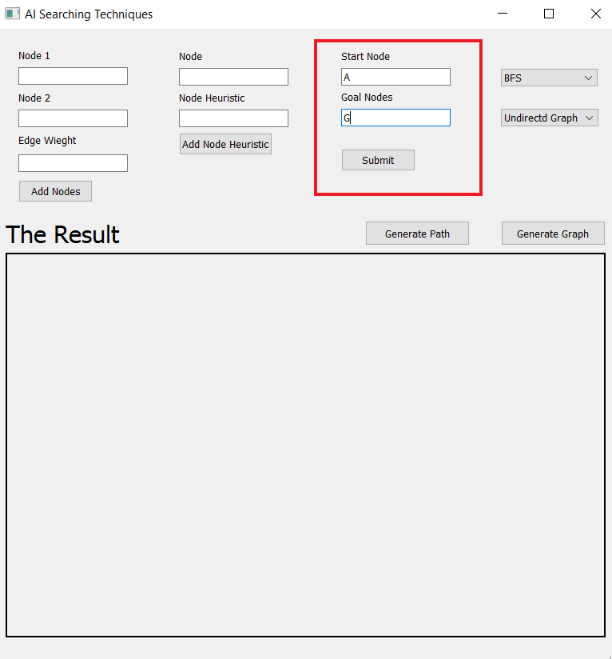

1. Choose the search type you desire (BFS, UCS, DFS, Greedy, A*) from the search type combo box

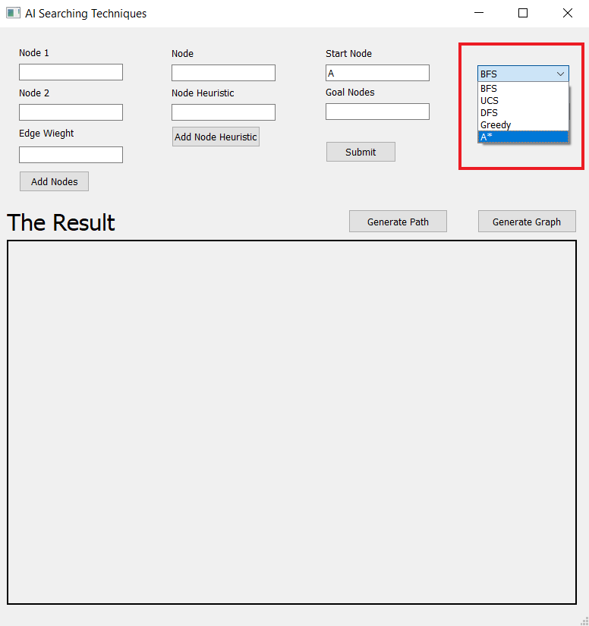

1. 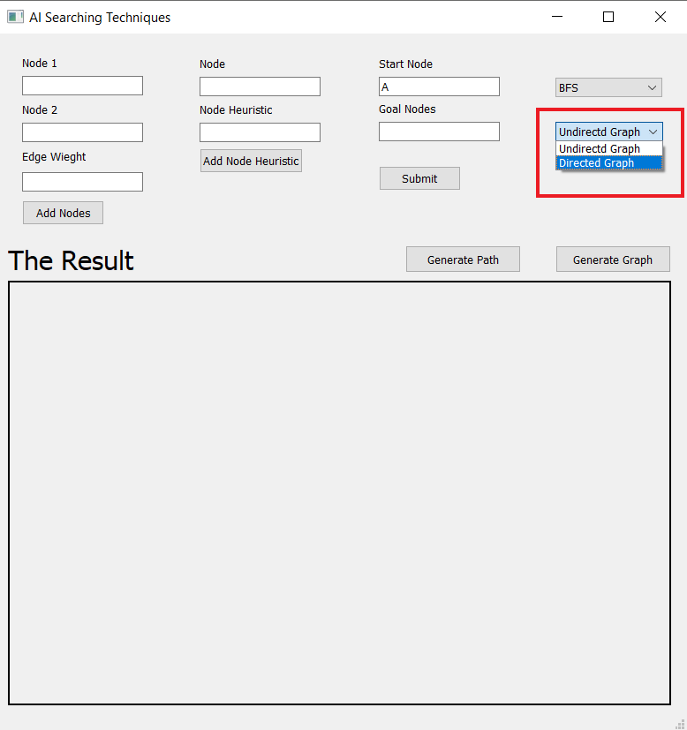Choose the graph type you desire (Undirected, Directed) from the graph type combo box
2. 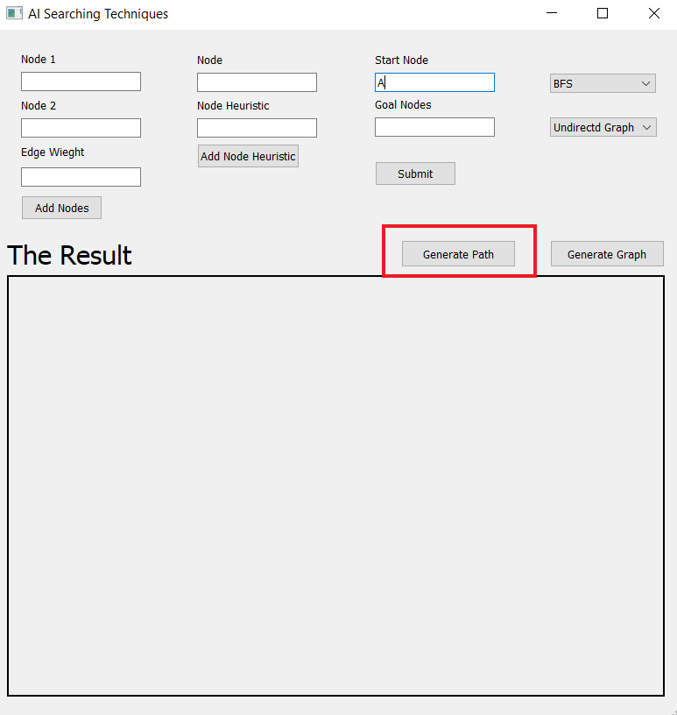Click on “Generate Path” button and the answer of the selected search type will be shown in “The Result” empty box

* 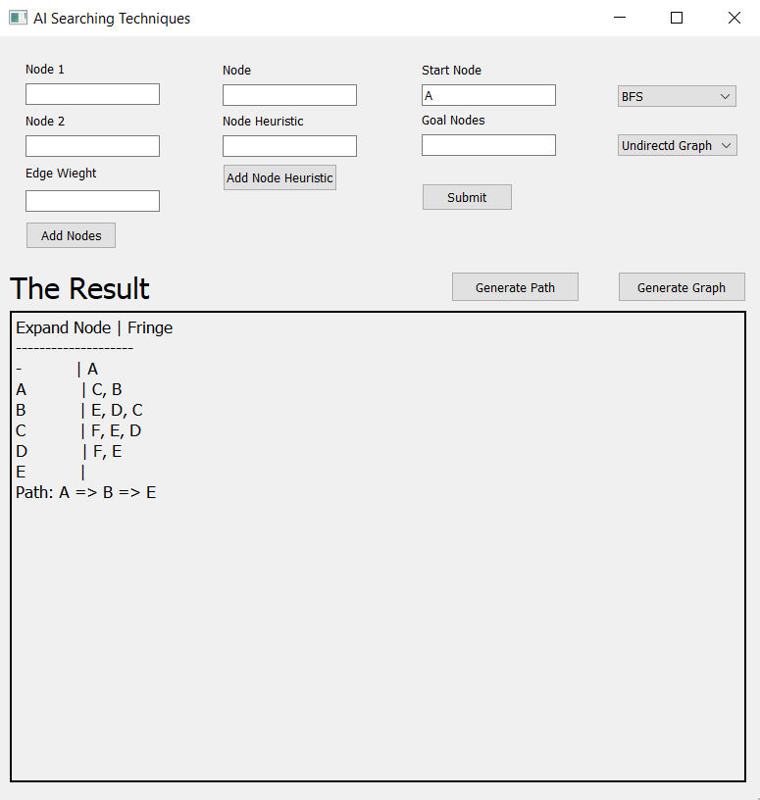The result of undirected BFS
* The result of directed BFS

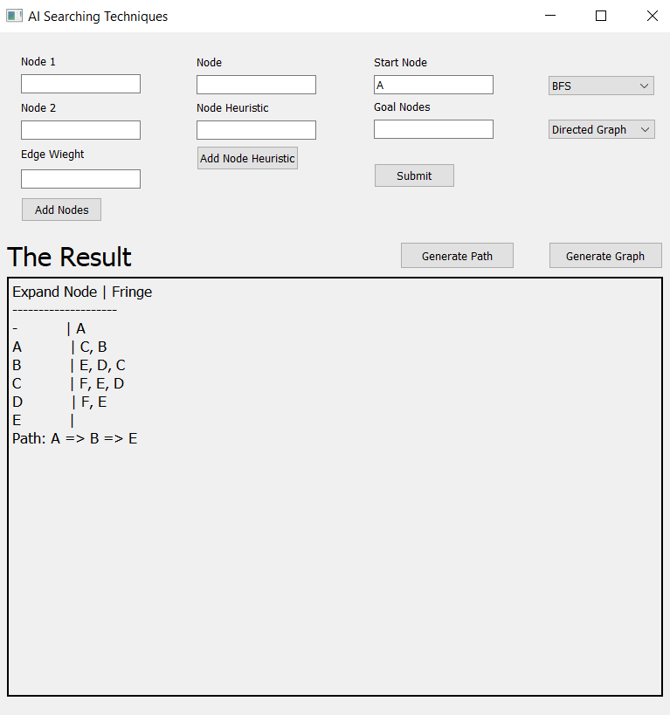

* 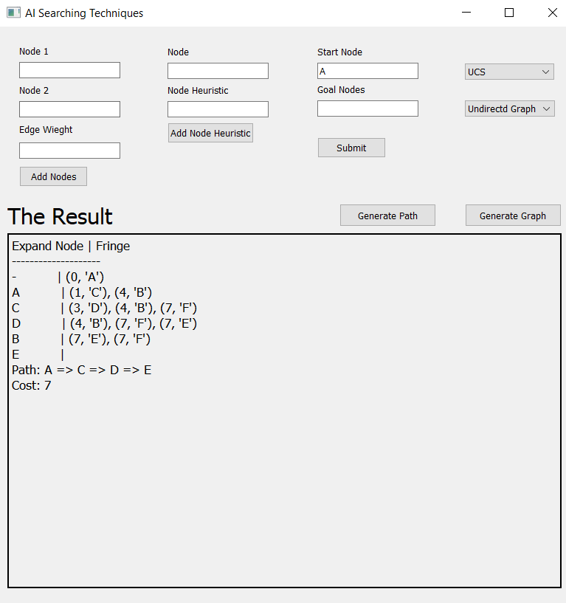The result of undirected UCS
* 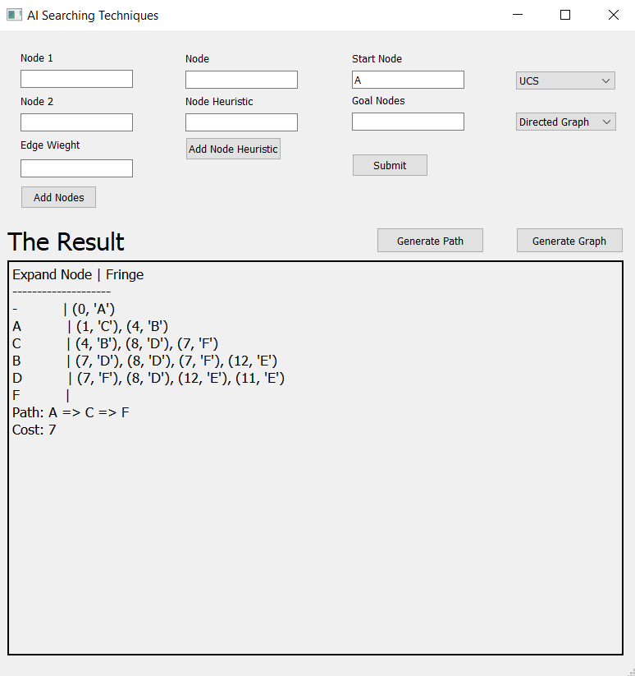The result of directed UCS
* The result of undirected DFS

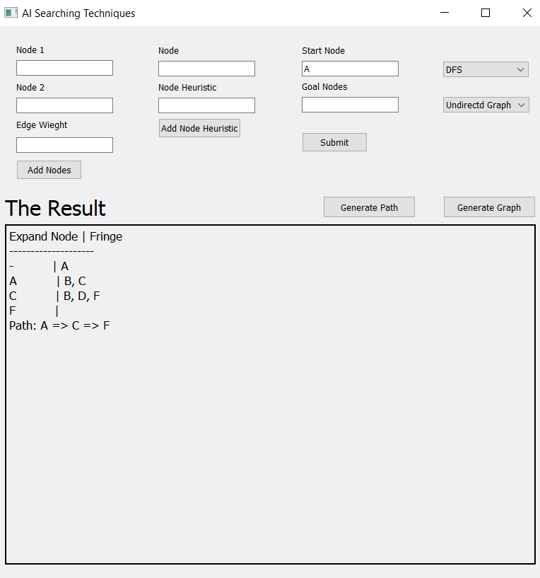

* The result of directed DFS

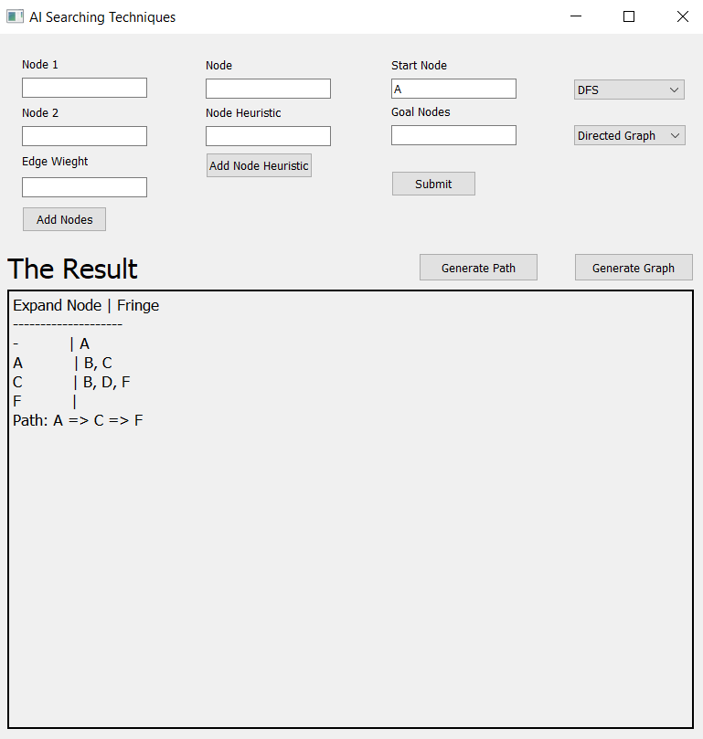

* 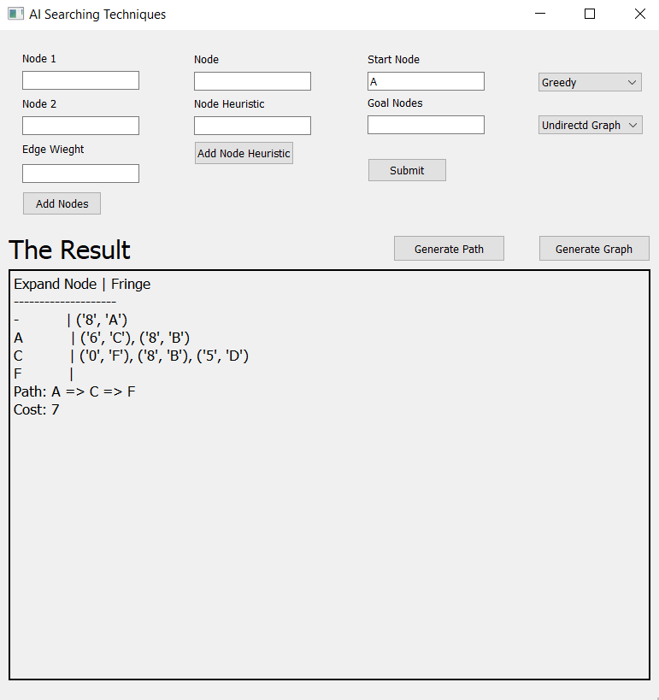The result of undirected Greedy

* The result of directed Greedy

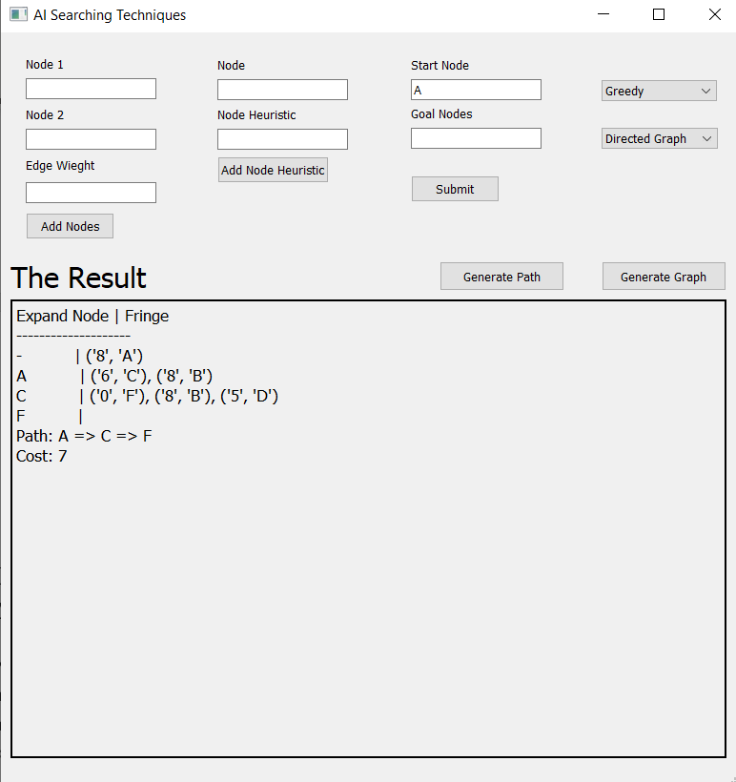

* The result of undirected A*

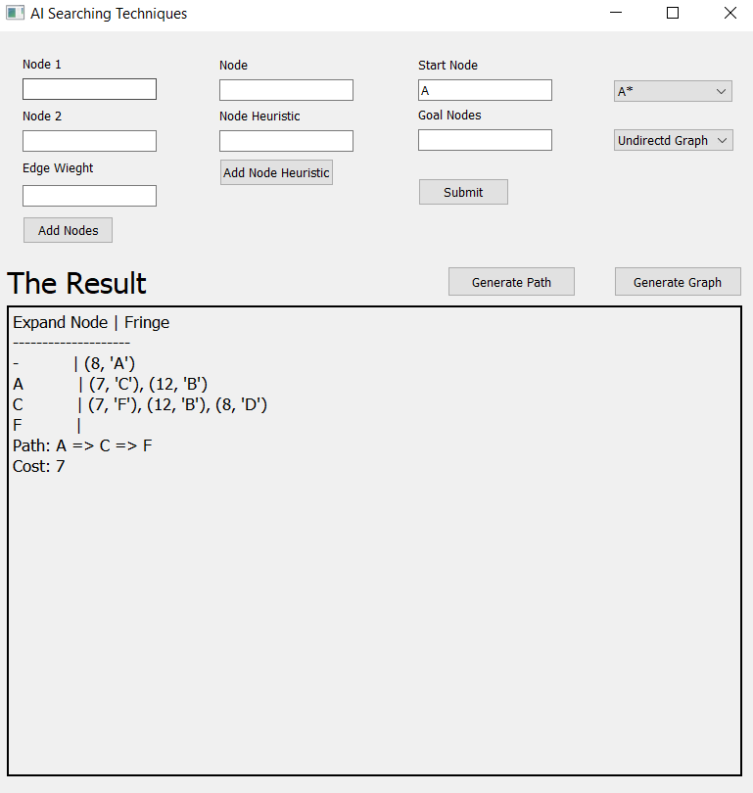

* The result of directed A*

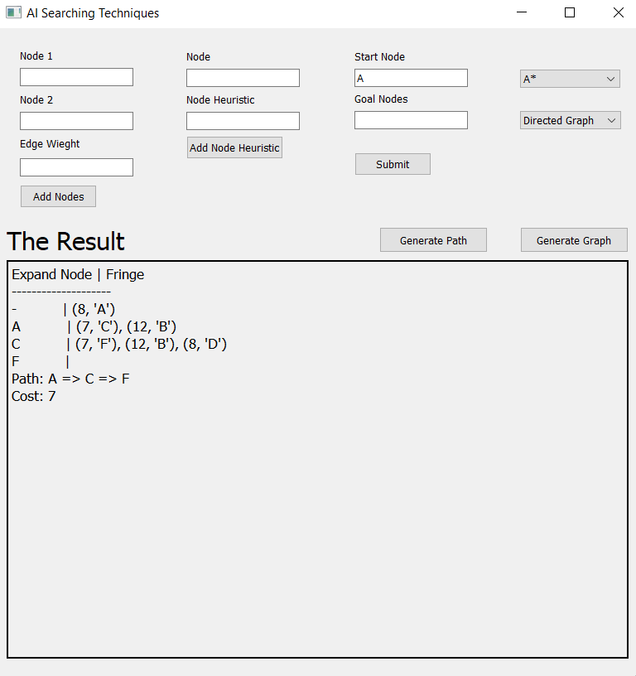

1. Click on “Generate Graph” button and the answer of the selected graph type will be shown in a new window

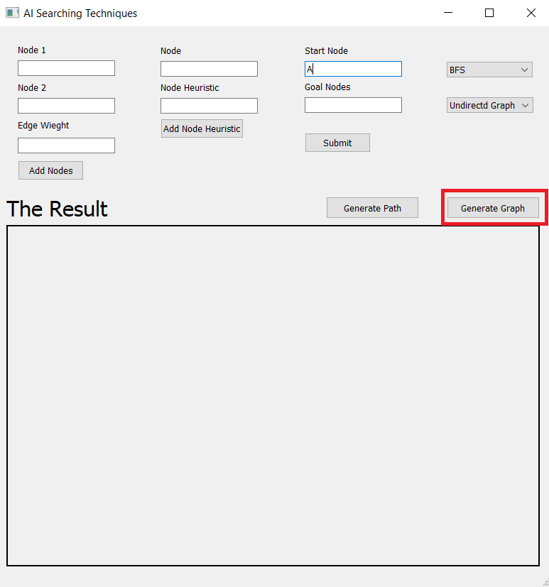

* The result of undirected graph

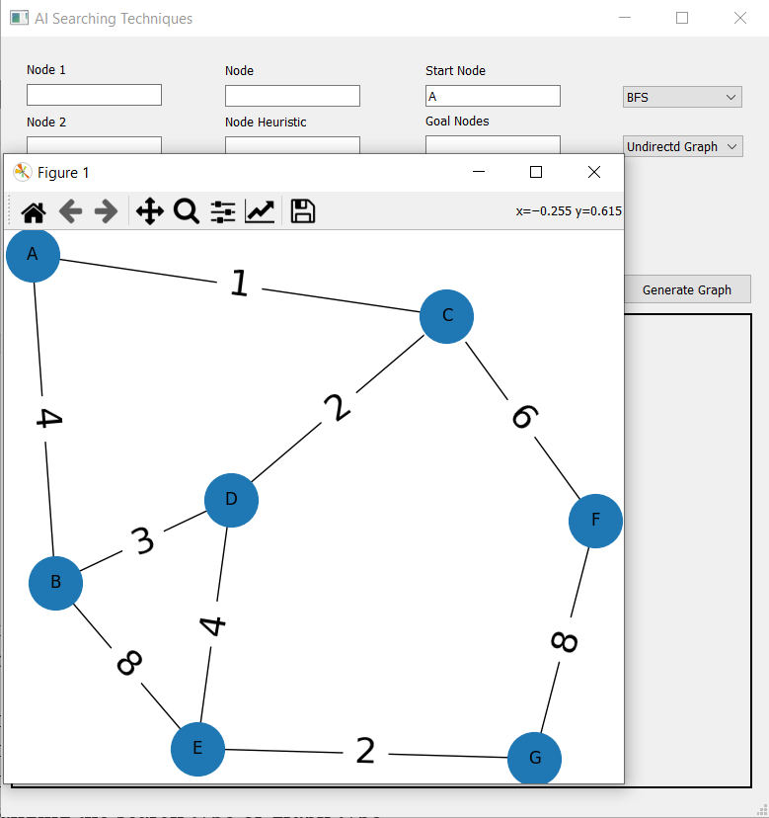

* The result of directed graph

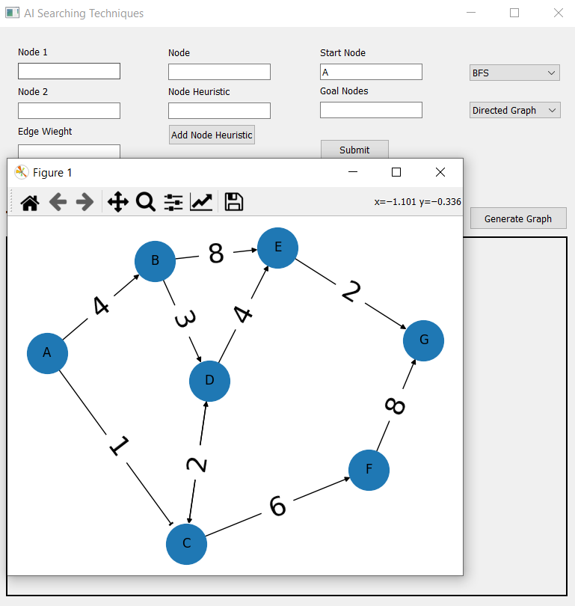

Note:

* You can skip step 2 if you will not select the (greedy or A*) search type
* You can use the same inputs to generate different paths and graphs by changing the search type or graph type
* The example we used in the demo:

|  |  |  |
| --- | --- | --- |
| **Node 1** | **Node 2** | **Edge Weight** |
| A | B | 4 |
| A | C | 1 |
| B | D | 3 |
| B | E | 8 |
| C | C | 0 |
| C | D | 7 |
| C | F | 6 |
| D | C | 2 |
| D | E | 4 |
| E | G | 2 |
| F | G | 8 |

|  |  |
| --- | --- |
| **Node** | **Heuristics** |
| A | 8 |
| B | 8 |
| C | 6 |
| D | 5 |
| E | 0 |
| F | 0 |
| G | 0 |

start is 'A'

Goals are {'G', 'E', 'F'}